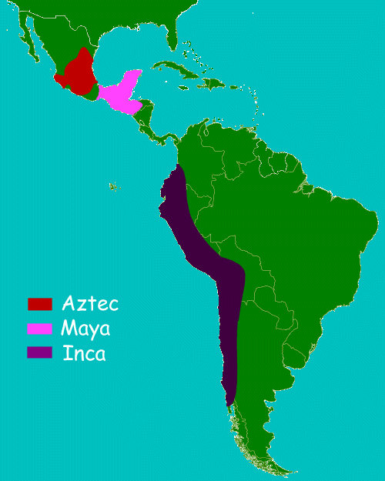

Aztecs
The Aztec Empire was located in central Mexico. It ruled much of the region from the 1400s until the Spanish arrived in 1519. Much of the Aztec society centered around their religion and gods. They built large pyramids as temples to their gods and went to war to capture people they could sacrifice to their gods.
The capital city of the Aztec Empire was Tenochtitlan. This city was founded in 1325 on an island in Lake Texcoco. At the height of its power, the city likely had a population of 200,000 people. At the center of the city was a large temple complex with pyramids and a palace for the king. The rest of the city was planned out in a grid-like fashion and divided up into districts. It had causeways built to get to the mainland and aqueducts to bring fresh water into the city.
The Aztec called their ruler the Tlatoani. The Empire reached its height under the rule of Tlatoani Montezuma I. Around 1517 the priests of the Aztecs began to see omens of doom. They felt that something bad was going to happen. They were right. In 1519 Spanish conquistador Hernan Cortes arrived in Mexico. By 1521 the Spanish had conquered the Aztecs. They tore down much of the city of Tenochtitlan and built their own city on the site called Mexico City.

Maya
The Maya civilization began as early as 2000 BC and continued to have a strong presence in Mesoamerica for over 3000 years until the Spanish arrived in 1519 AD. The Maya were organized into powerful city-states. Over the course of Maya history, different city-states came into power such as El Mirador, Tikal, Uxmal, Caracol, and Chichen Itza.
The Maya were located in Central America in a region that is today made up of southern Mexico, the Yucatan Peninsula, Guatemala, Belize, and northern El Salvador. They built hundreds of cities filled with large stone structures. The Maya are perhaps best known today for their many pyramids. They built pyramids to their gods that towered hundreds of feet tall above the jungle.
The Maya were the only American civilization to develop an advanced written language. They also excelled in mathematics, art, architecture, and astronomy. The golden age of the Maya civilization occurred during what is called the Classic Period from 250 AD to 900 AD.

Inca
The Inca Empire was centered in Peru and ruled over much of the west coast of South America from the 1400s to the time of the Spanish arrival in 1532. This wide ranging empire did not have the wheel, iron tools, or a writing system, but its complex government and system of roads created a society where everyone had a job, a home, and something to eat.
The emperor of the Inca was known as the Sapa Inca. The first Sapa Inca was Manco Capac. He founded the Kingdom of Cuzco around 1200 AD. The city of Cuzco would remain the capital of the empire as it expanded in the coming years. The Inca expanded into a great empire under the reign of Pachacuti. Pachacuti created the Inca Empire which the Inca called the Tawantinsuyu. At its height, the Inca Empire had an estimated population of over 10 million people.
The Inca were conquered by the Spanish and conquistador Francisco Pizarro in 1533. The empire was already severely weakened by civil war and diseases such as smallpox when Pizarro arrived.

